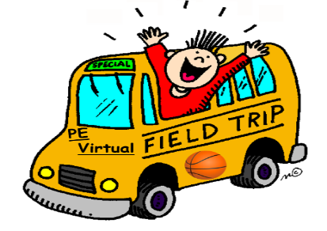
Physical Education Virtual Field Trips

FOOTBALL
https://aha-nflplay60.discoveryeducation.com/field-trip
Super Bowl LI VFT https://aha-nflplay60.discoveryeducation.com/super-bowl-li-vft
Roadmap to a Healthy Heart https://aha-nflplay60.discoveryeducation.com/roadmap
https://footballbythenumbers.discoveryeducation.com/virtual-field-trip
Huddle up and Get Moving https://safeyoutube.net/w/yNx9

BASKETBALL

Careers in the NBA https://www.discoveryeducation.com/learn/nba-partnership/
NBA: https://safeyoutube.net/w/XYx9
Careers That Count with NBA https://safeyoutube.net/w/UQx9
NBA Storytellers: All-Star https://safeyoutube.net/w/5Wx9

BASEBALL
MLB Careers https://www.discoveryeducation.com/learn/mlb-partnership/
Virtual google earth tour of baseball stadiums. https://safeyoutube.net/w/bOhA

Field trip to baseball stadium: https://safeyoutube.net/w/rZhA

TENNIS
Careers beyond the court https://www.usta.com/en/home/coach/professional-tennis-management/national/careers-beyond-the-court-virtual-field-trip.html
https://safeyoutube.net/w/PKhA

Soccer
How to Play Soccer Field Trip https://safeyoutube.net/w/IXhA

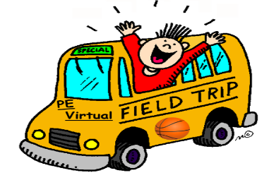
Bowling
How to Bowl; Bowling alley field trip https://safeyoutube.net/w/YniA

