FITNESS BINGO
3rd-5th Graders: Have a parent/guardian initial each square as your complete it!

Mindfulness  Draw for 5 minutes | Read at least 20 pages in a book. | Cook one new healthy recipe with your family | Do 6 laps around your home. | Eat 3 cups of veggies in a day.
Try something new!  Write below:  _____________ | 30 jumping jacks | 5 push ups  20 squats  20 curl ups | Play outside for 20 minutes. | 20 Lunges  (alternate legs)  20 Calf Raises  (up on your toes)
30 catches with a ball or item of your choice | Your choice of fitness based activity for 20 minutes | FREE  SPACE | Go for a 20 minute walk. | Play a game with your family. (cards, sport, board game, etc.)
45 second plank | Play outside for 20 minutes | Eat 3 cups of veggies in a day | Read at least 10 pages in a book. | 10 push ups  10 Curl Ups  10 Squats  10 second Butterfly Stretch
Give a compliment to each person in your house. | Jog in place for 1 minute | Your choice active activity  For 10 minutes | Drink at least 5 cups of water in a day. | Help clean the germs in at least one room in your home.

Kindergarten-2nd grade: Do each exercise 10 times. Complete 5 in a row to win!
Shoulder Touches  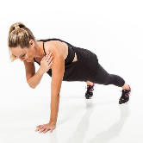 | Jumping Rope  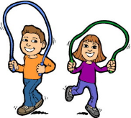 | Hopping on one foot  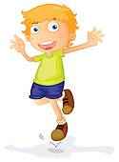 | Arm Circles  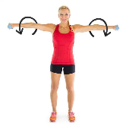 | Cross Country Skiing  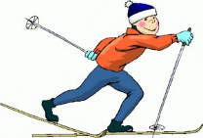
Superman  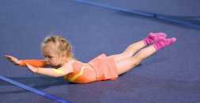 | Push Ups  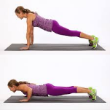 | Popcorn   | Backstroke   | Raise the Roof  
Jumping Jacks  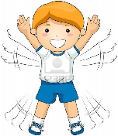 | Ski Jumps  (jump side to side)  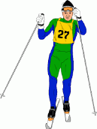 | Washing Machine  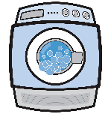 | Apple Picking  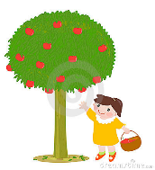 | Bicycle  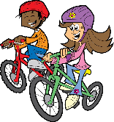
Mountain Climbers  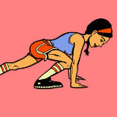 | Swimming  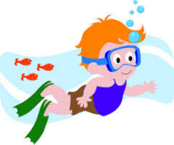 | Jumping in Place   | Running in Place  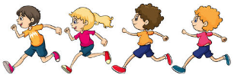 | Squat  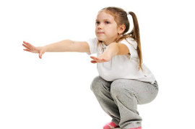
Plank  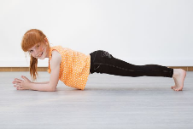 | 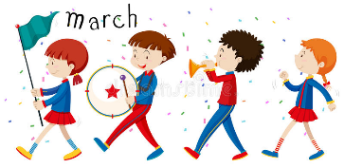 | Windmill   | Twister  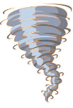 | Lunges  