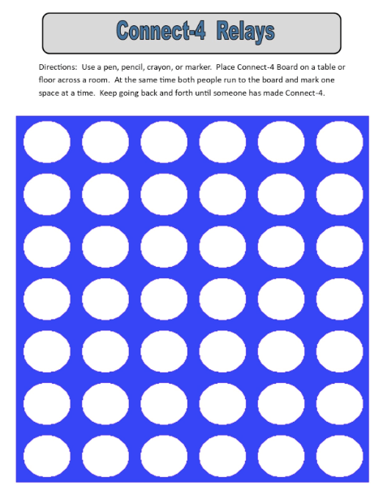

How To Play:
- Print out connect 4 sheet or design your own or use the actual game if you have it.
- You will need two markers (1 for you and the 2nd for a family member)
- You and a family member will start at the same distance, run to the Connect 4 board and mark one space at a time
- When finished marking one space run back to the starting line and then run back to the board
- Continue doing this until you have a connect 4
- Have FUN!

